Thunder Road Seniors
Clover Creek
Dinner Theatre
Fishkill, NY

October 17, 2019
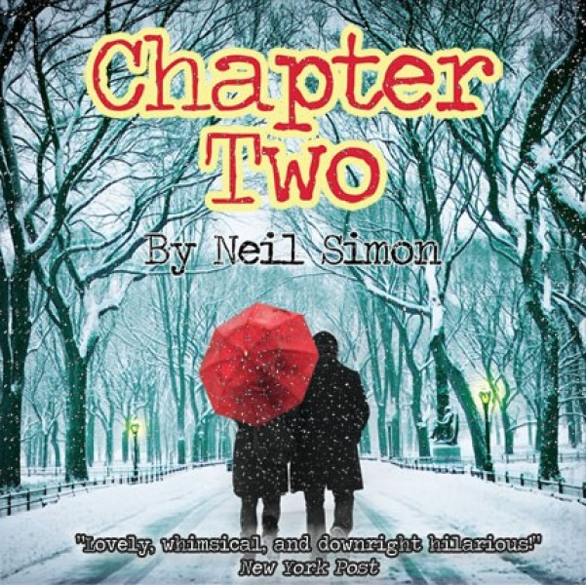

Recent widower, writer George Schneider, is encouraged by his younger
Brother Leo to start dating again. Then Leo comes up with Jennie Malone.
It is a hilarious, farcical subplot.

Cost tba

