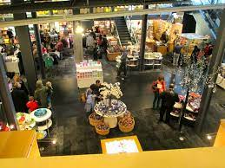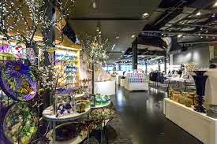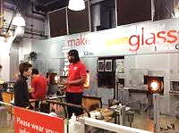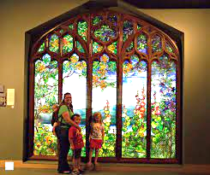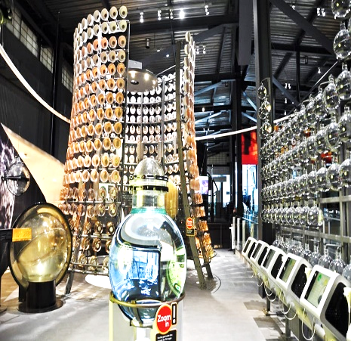

**Thunder Road Seniors**

Corning Glass Museum

Corning, NY

Thursday, October 5, 2023

Bus arrives at Center 6:30an. Leaving Center 7:00am. 20-minute rest stop included.

Bus departs for home 4:45pm

**Self-guided tour and live demo schedules, and a sandblasting workshop (make a wineglass to take home) divided into two groups, an hour each. $15 Café Lunch voucher is included**.

Cost $20.00 Members/$30.00 Social Members

Trip Committee: Esther Cioffi, Jackie Mendini, Nancy Copeman

You also may leave a message with TRS office 518-554-8588 and someone will return your call.