Thunder Road Seniors
May 13, 2019

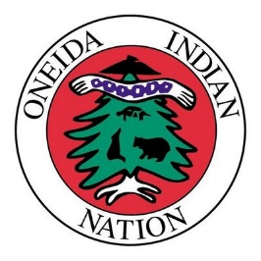
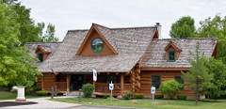
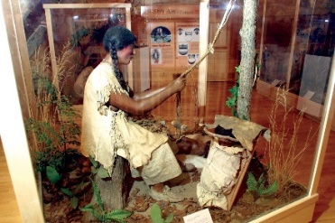
Shako:wi Oneida Indian Cultural Center

(You must spend at least one hour at the museum) and

Turning Stone Casino

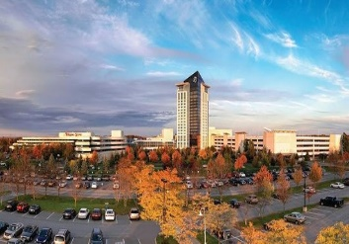
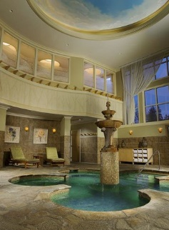
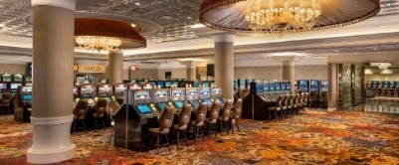

Cost $2.00/$4.00

Bus arrives at HBK Center 7:00am and
leaves promptly at 7:30am

