Thunder Road Seniors
VILLA ROMA RESORT
Doo Wop Show and Luncheon
Tuesday, June 13th
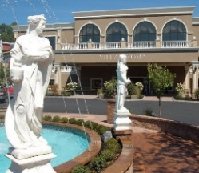
Join us for the day at the Villa Roma Resort, Callicoon, NY. Upon arrival you will be welcomed with Coffee, Cake & Free Time till Lunch.

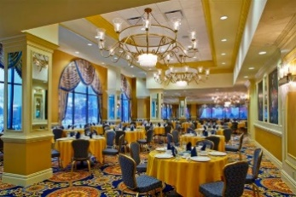
At Noon you will have a delicious
Four-Course Luncheon served in the Main Dining Room. Entrees: Roast Loin of Pork, Chicken Parmigiana over Linguini, or Flounder Francese.
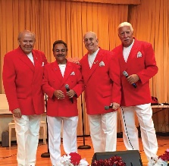
Following lunch enjoy the Doo Wop show starring Joey and the Paradons who have been performing since 1959. Their unique sound and harmony will take you on a trip performing your favorite hits from the 50’s and 60’s!
Cost $35.00 Member /$45.00 Social
Bus arrives at HBK Center 7:00am. Bus leaves at 7:30am.
Bus returns home approximately 6:00pm.

Trip Committee: Esther Cioffi, Jackie Mendini, Nancy Copeman
You also may leave a message with TRS office 518-554-8588 and someone will return your call.

When signing up please advise choice of meal (see above) and if you have any special needs.

