Thunder Road Seniors
Rip Van Winkle Boat Ride
July 10, 2019

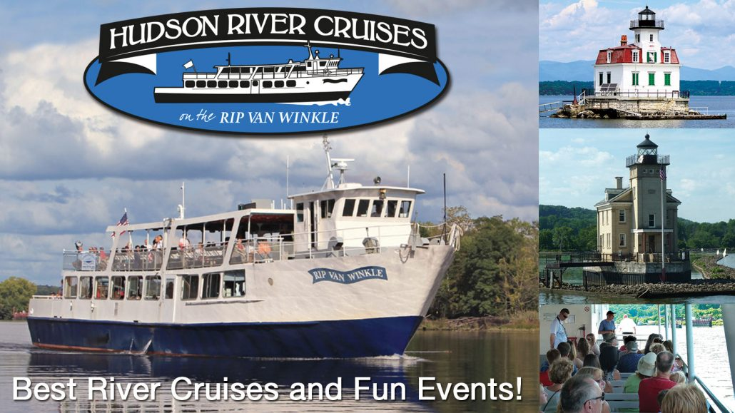

Sail on the Hudson River at 2:30pm.
Dinner at 4:30pm - Mariners Restaurant
in Kingston

Cost TBS

