Thunder Road Seniors
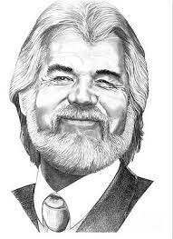
Aqua Turf Club Southington, CT

Tuesday August 15th
Richie Mitnick presents:
“Come Fly with Me”
A Journey Through the Decades: From Frank Sinatra, Kenny Rogers &
Tim McGraw to Dionne Warwick, Diana Ross, & Roberta Flack.

Performed by:
Joe Saimeri & Ethel Lee

Show and lunch included.
All entrees served family style - Baked Scrod & Chicken Marsala, complimentary coffee & donuts, glass of beer or wine, dessert, and complimentary door prizes.

$45.00 MEMBERS/$55.00 SOCIAL
Bus arrives at Center 8:00am
Bus leaves Center 8:30am
Returns to Center approximately 6:30pm

See Trip Committee: Esther Cioffi, Jackie Mendini, Nancy Copeman or call TRS office 518-554-8588 and leave message for someone to contact you.

