Thunder Road Seniors

Waterbury Center, VT
August 21, 2019
Cold Hollow Cider Mill
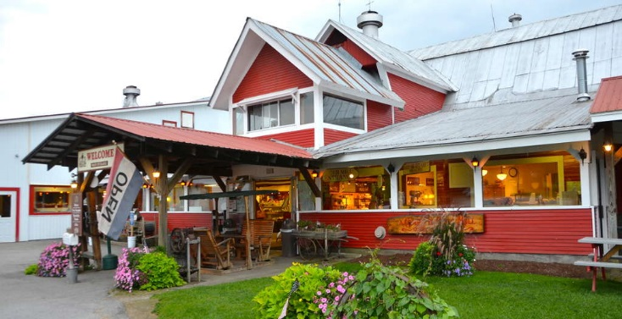
Free samples cider, jams,
jellies and mustards.
Tasting room for hard cider.

Lake Champlain Chocolates Cabot Cheese Center

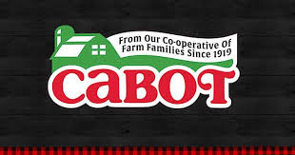
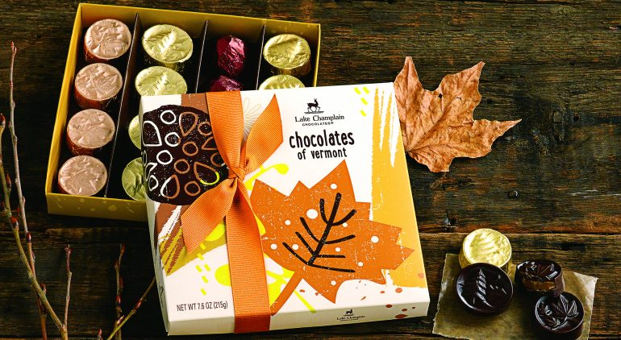

Green Mountain Coffee
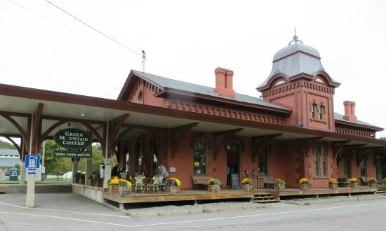

Free Coffee of the Day Sample

Cost tba

