Thunder Road Seniors
Connecticut Rail & Sail
October 3, 2019

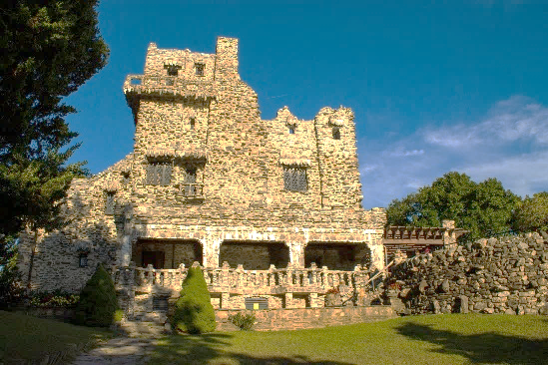
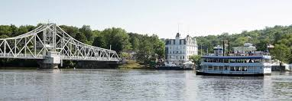
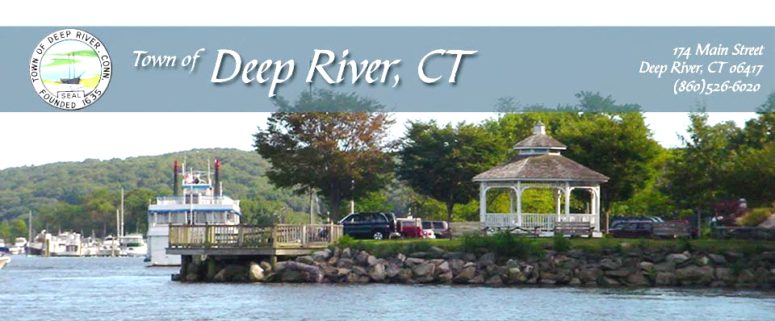
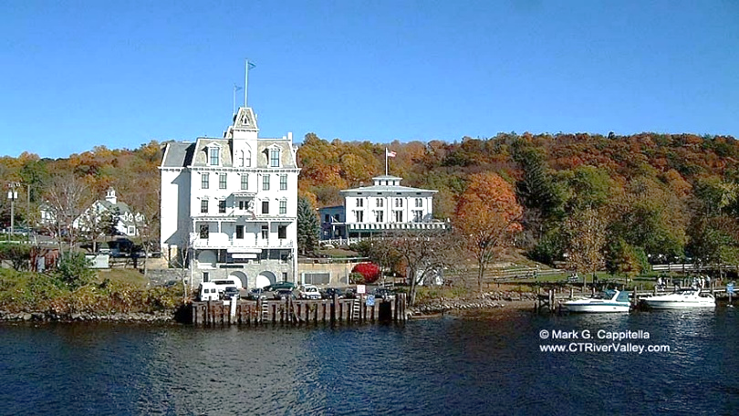
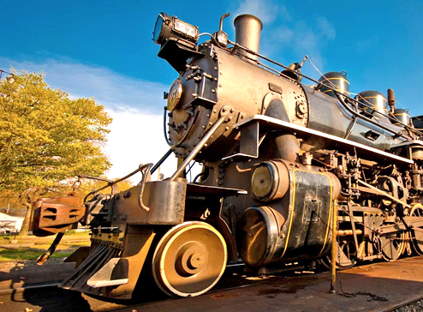

Spend the day enjoying a sightseeing journey and delicious lunch
aboard the Essex Steam Train. Have lunch in restored 1920’s
Pullman Diners (3 course meal on train). Essex Train Station
built 1892. Then board the Becky Thatcher Riverboat, take
pleasure seeing the Gillette Castle, Deep River Landing,
Goodspeed Opera House and Haddam Swing Bridge as you cruise
the Connecticut River through lush scenery.

Cost tba

